**NEUROMODULATION SOCIETY MEETING**

**The Neuromodulation Society of Australia and New Zealand is holding its 8th Annual Scientific Meeting in Canberra on Sunday, 17th March at the National Convention Centre.**

**Major Theme-Is Faster Better?**

The morning sessions will focus on the latest data analysis and use of high frequency SCS and peripheral nerve stimulation. The afternoon theme of “Difficult Vignettes” will focus on a panel of experts discussing approaches to treating thoracic, peri-ocular, headache, perineal and neck neuropathic pain.

**International guest speakers include :**

Dr Jean-Pierre Van Buyten, Belgium

Dr Dong Chul Lee, USA

Dr Lisa Johanek, USA

Dr Liong Liem, the Netherlands

**Early Bird Registration for the day workshop is $180 to 1st Feb**

**An optional dinner meeting will follow @ $120/pp**

**Please see link below for registration:**

<http://www.dcconferences.com.au/aps2013/>

Should you have any queries regarding your registration or the conference in general please do not hesitate to contact

DC Conferences  
Suite 103, Level 1  
3 West Street  
North Sydney NSW 2060  
T: 612 9954 4400  
F: 612 9954 0666

 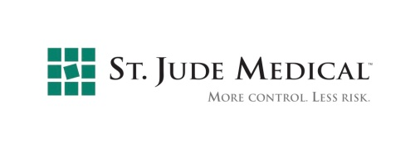

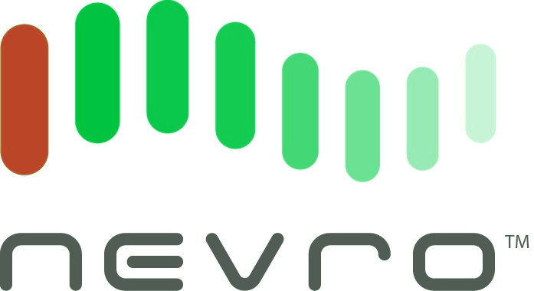 cid:1D032626-E4A8-44E3-8E98-9B459762626D